# FAQs

[Home](https://webcf.waybackmachine.org/web/20180829195532/http:/frame-online.eu/)  [FRAME ARCHITECTURE](https://webcf.waybackmachine.org/web/20180829195532/http:/frame-online.eu/frame-architecture)  FAQs

*feel free to contact us:*  info(at)frame-online.net

The following FAQs relate to a technical and detailed understanding of the FRAME Architecture. If you have questions that are not of a such a technical nature then please look at “[FIRST VIEW](https://webcf.waybackmachine.org/web/20180829195532/http:/frame-online.eu/first-view)“. If neither of these are helpful please contact us at [info(at)frame-online.net](https://webcf.waybackmachine.org/web/20180829195532/mailto:info@frame-online.net).

[**What is an Actor?**](https://webcf.waybackmachine.org/web/20180829195532/http:/frame-online.eu/frame/faqs/what-is-an-actor)  
An Actor is a specifc sub-set of a Terminator – see [“What is a Terminator?”](https://webcf.waybackmachine.org/web/20180829195532/http:/frame-online.eu/frame/faqs/what-is-a-terminator)

[**What is a Communications View?**](https://webcf.waybackmachine.org/web/20180829195532/http:/frame-online.eu/frame/faqs/what-is-a-communications-view)  
A Communications View contains descriptions of the Physical Data Flows that pass between Sub-systems (and Modules) in the Physical View…

[**What is a Context Diagram?**](https://webcf.waybackmachine.org/web/20180829195532/http:/frame-online.eu/frame/faqs/what-is-a-context-diagram)  
An important part of the Functional View is the Context Diagram. This shows the ITS as a single item and the links needed by the functionality within it to communicate with the entities outside it (i.e. Terminators). It is useful for two reasons. Firstly it enables the system…

[**What is a Data Flow?**](https://webcf.waybackmachine.org/web/20180829195532/http:/frame-online.eu/frame/faqs/what-is-a-data-flow)  
The Data Flows link the Functions to each other, to Terminators and Data Stores. They enable data to be moved around within the Architecture…

[**What is a Data Flow Diagram (DFD)?**](https://webcf.waybackmachine.org/web/20180829195532/http:/frame-online.eu/frame/faqs/what-is-a-data-flow-diagram-dfd)  
Data Flow Diagrams (DFDs) illustrate the way that the functionality within each Functional Area is organised into a hierarchy of High-level and Low-level Functions. They also show how the Functions are linked to each other, and to the Terminators and Data Stores through Data Flows. There is one…

[**What is a Data Store?**](https://webcf.waybackmachine.org/web/20180829195532/http:/frame-online.eu/frame/faqs/what-is-a-data-store)  
The Data Stores are used to hold data that is used by two or more Functions within a Functional Area. Each has its own unique number and name. The first digit of the number is the Functional Area in which the Data Store resides. The name indicates the type of data that the Store contains…

[**What is a Function?**](https://webcf.waybackmachine.org/web/20180829195532/http:/frame-online.eu/frame/faqs/what-is-a-function)  
The functionality in each Functional Area is decomposed into several Functions that form a hierarchical set of High-level and Low-level Functions.  
Low-level Functions contain simple (un-complex) functionality which is easy to describe, and thus contain the lowest level of…

[**What is a Functional Area?**](https://webcf.waybackmachine.org/web/20180829195532/http:/frame-online.eu/frame/faqs/what-is-a-functional-area)  
At its highest level, the Functional View consists of a number of Functional Areas, each of which contains the functionality that is responsible for a specific area of operations. This functionality is provided by a set of Functions and their related Data Stores. Each Functional Area has…

[**What is a Functional View?**](https://webcf.waybackmachine.org/web/20180829195532/http:/frame-online.eu/frame/faqs/what-is-a-functional-view)  
A Functional View (sometimes called a Logical View, or even a Logical Architecture by others) shows the functionality that will be required to fulfil the User Needs, and hence the Stakeholder Aspirations. When using the FRAME Architecture the Functional View…

[**What is a Physical View?**](https://webcf.waybackmachine.org/web/20180829195532/http:/frame-online.eu/frame/faqs/what-is-a-physical-view)  
Once the Functional View is complete, the architecture team allocates each function and data store to be located, either within a sub-system (see figure below), or within a module that is part of a sub-system. Once this has been completed the component (sub-system or module)…

[**What is a Stakeholder Aspiration?**](https://webcf.waybackmachine.org/web/20180829195532/http:/frame-online.eu/frame/faqs/what-is-a-stakeholder-aspiration)  
Stakeholder Aspirations are statements that express the expectations and desires of the various stakeholders for the services that the final ITS implementation will provide. Although they should be written by the stakeholders, experience has shown that they often need help from the…

[**What is a Terminator?**](https://webcf.waybackmachine.org/web/20180829195532/http:/frame-online.eu/frame/faqs/what-is-a-terminator)  
A Terminator is an entity that represents a part of the outside world with which the Framework Architecture interacts through an interface. It may be a person, or a system with which data can be exchanged, or a physical entity from which data can be obtained, such as the atmosphere, or road…

[**What is a User Need?**](https://webcf.waybackmachine.org/web/20180829195532/http:/frame-online.eu/frame/faqs/what-is-a-user-need)  
User Needs provide a formalised description of the Services that will be provided through the deployment of the results from the creation of an ITS Architecture. What the Stakeholders themselves want should be expressed in their own words in their Stakeholders’ Aspirations. These Aspirations…

## What is an Actor?

[Home](https://webcf.waybackmachine.org/web/20190124064704/http:/frame-online.eu/)  [FRAME ARCHITECTURE](https://webcf.waybackmachine.org/web/20190124064704/http:/frame-online.eu/frame-architecture)  [FAQs](https://webcf.waybackmachine.org/web/20190124064704/http:/frame-online.eu/frame-architecture/faqs)  What is an Actor?

An Actor is a specifc sub-set of a Terminator – see “[What is a Terminator?](https://webcf.waybackmachine.org/web/20190124064704/http:/frame-online.eu/frame/faqs/what-is-a-terminator)“

## What is a Communications View?

[Home](https://webcf.waybackmachine.org/web/20190124064624/http:/frame-online.eu/)  [FRAME ARCHITECTURE](https://webcf.waybackmachine.org/web/20190124064624/http:/frame-online.eu/frame-architecture)  [FAQs](https://webcf.waybackmachine.org/web/20190124064624/http:/frame-online.eu/frame-architecture/faqs)  What is a Communications View?

A Communications View contains descriptions of the Physical Data Flows that pass between Sub-systems (and Modules) in the Physical View. See also “[What is a Physical View?](https://webcf.waybackmachine.org/web/20190124064624/http:/frame-online.eu/frame/faqs/what-is-a-physical-view)“.

A Communications View will contain statements, or examples, of the data that flows between Sub-systems (and Modules) and from which communications specifications can be written. Some links may require the use of existing communications standards, others may require a new communication standard to be written. In the latter situation the corresponding part of the Communications View can used as a starting point.

## What is a Context Diagram?

[Home](https://webcf.waybackmachine.org/web/20190124064629/http:/frame-online.eu/)  [FRAME ARCHITECTURE](https://webcf.waybackmachine.org/web/20190124064629/http:/frame-online.eu/frame-architecture)  [FAQs](https://webcf.waybackmachine.org/web/20190124064629/http:/frame-online.eu/frame-architecture/faqs)  What is a Context Diagram?

An important part of the Functional View is the Context Diagram. This shows the ITS as a single item and the links needed by the functionality within it to communicate with the entities outside it (i.e. Terminators). It is useful for two reasons. Firstly it enables the system boundary to be defined showing what is inside the ITS implementation and what is not. Secondly it enables definitions to be produced of the way in which the functionality inside the ITS expects the outside entities to behave. The same Context Diagram is also part of the Physical View.

The Diagram below is the Context Diagram for the FRAME Architecture.

[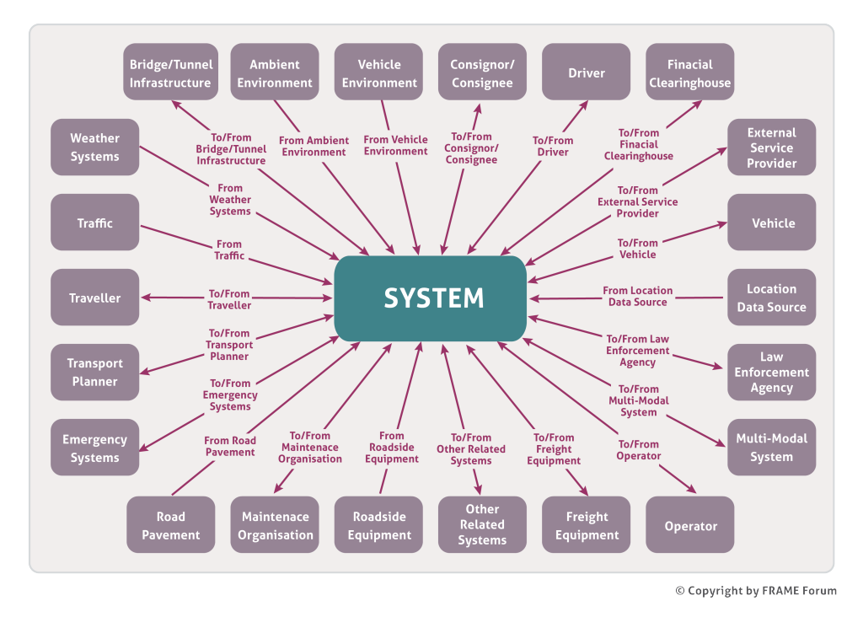](https://webcf.waybackmachine.org/web/20190124064629/http:/frame-online.eu/wp-content/uploads/2015/03/FRAME-Context-Diagram-n.png)

## What is a Data Flow?

[Home](https://webcf.waybackmachine.org/web/20190124064743/http:/frame-online.eu/)  [FRAME ARCHITECTURE](https://webcf.waybackmachine.org/web/20190124064743/http:/frame-online.eu/frame-architecture)  [FAQs](https://webcf.waybackmachine.org/web/20190124064743/http:/frame-online.eu/frame-architecture/faqs)  What is a Data Flow?

The Data Flows link the Functions to each other, to Terminators and Data Stores. They enable data to be moved around within the Architecture and are of the following three types:

* Functional Data Flows – carry data from one Function to another, or to/from the Data Stores.
* Terminator Data Flows – carry data to/from Terminators.
* Inter-Functional Area Data Flows – carry data from Functions in one Functional Area to those in another Functional Area.

All Data Flows have names that start with letter codes that define either the Functional Area in which they reside, the Terminator with which they are associated, or the Functional Areas that they link. A summary of these codes can be found in the ‘Acronym Definition’ page of the Browsing Tool.

## What is a Data Flow Diagram (DFD)?

[Home](https://webcf.waybackmachine.org/web/20190124064634/http:/frame-online.eu/)  [FRAME ARCHITECTURE](https://webcf.waybackmachine.org/web/20190124064634/http:/frame-online.eu/frame-architecture)  [FAQs](https://webcf.waybackmachine.org/web/20190124064634/http:/frame-online.eu/frame-architecture/faqs)  What is a Data Flow Diagram (DFD)?

Data Flow Diagrams (DFDs) illustrate the way that the functionality within each Functional Area is organised into a hierarchy of High-level and Low-level Functions. They also show how the Functions are linked to each other, and to the Terminators and Data Stores through Data Flows. There is one DFD for each Functional Area, and within them, one DFD for each High-level Function. Each DFD is numbered and named. The first digit of the number identifies the Functional Area. Any second and subsequent digits correspond to the High-level Function that the DFD represents. The name of each DFD is either that of the Functional Area or the High-level Function that each DFD represents

The DFDs contain rectangular shapes, representing the Functions, and (sometimes) cylindrical shapes representing Data Stores. Data Flows are represented by lines with an arrow indicating the direction of the flow of data. The name of the Data Flow is written within the line. The sizes of the rectangles and cylindrical shapes vary from one DFD to another and have no special significance.

## What is a Data Store?

[Home](https://webcf.waybackmachine.org/web/20190124064639/http:/frame-online.eu/)  [FRAME ARCHITECTURE](https://webcf.waybackmachine.org/web/20190124064639/http:/frame-online.eu/frame-architecture)  [FAQs](https://webcf.waybackmachine.org/web/20190124064639/http:/frame-online.eu/frame-architecture/faqs)  What is a Data Store?

The Data Stores are used to hold data that is used by two or more Functions within a Functional Area. Each has its own unique number and name. The first digit of the number is the Functional Area in which the Data Store resides. The name indicates the type of data that the Store contains. Their existance does not imply the use of any particular physical design or storage methodology.

The description of each Data Store contains details of what data is held in the Store. Taken together, the Data Store descriptions provide the Information View representation of the Framework Architecture.

## What is a Function?

[Home](https://webcf.waybackmachine.org/web/20190124064748/http:/frame-online.eu/)  [FRAME ARCHITECTURE](https://webcf.waybackmachine.org/web/20190124064748/http:/frame-online.eu/frame-architecture)  [FAQs](https://webcf.waybackmachine.org/web/20190124064748/http:/frame-online.eu/frame-architecture/faqs)  What is a Function?

The functionality in each Functional Area is decomposed into several Functions that form a hierarchical set of High-level and Low-level Functions.

Low-level Functions contain simple (un-complex) functionality which is easy to describe, and thus contain the lowest level of functionality in each Functional Area. The Functional Requirements provide details of what the Functions actually do with the data that they receive in order to produce the data that they send out.

High-level Functions are groups of Low-level Functions. They are used to represent these Low-level Functions at higher levels in the hierarchy in order to make it easier to understand the overall functionality within a Functional Area.

Each Function has a number and a name. The numbers are used to identify the position of each Function in the hierarchy within each Functional Area, whilst the names are a simplified expression of what the Function does.

**An example High Level Function:**

6.6 Provide Traveller Information

This High-level Function shall provide facilities that enable information to be provided to Travellers, either at the roadside, or by other means.  Information about traffic conditions shall be provided at the roadside, but other forms of information, e.g. about Points of Interest, shall be available to Travellers through other mechanisms, e.g. a nomadic device.

**An example Low Level Function:**

6.6.3 Output Travel Information

This Function shall be capable of providing the following facilities:  
(1) The ability to take responsibility for the output of information about road conditions, PT services, conditions of other transport modes, Points of Interest (POI) and Personal Services (PS) to Travellers.  
(2) The information output to the Traveller shall be provided by the Travel Information Operator through the Produce Traveller Information Function.  
(3) The ability to output the information in a form that is easy to understand and be suitable for those with disabilities.  
(4) The ability to continuously display the particular information that is being output until replaced by other information or the output is cancelled by the Operator.

## What is a Functional Area?

[Home](https://webcf.waybackmachine.org/web/20190124064644/http:/frame-online.eu/)  [FRAME ARCHITECTURE](https://webcf.waybackmachine.org/web/20190124064644/http:/frame-online.eu/frame-architecture)  [FAQs](https://webcf.waybackmachine.org/web/20190124064644/http:/frame-online.eu/frame-architecture/faqs)  What is a Functional Area?

At its highest level, the Functional View consists of a number of Functional Areas, each of which contains the functionality that is responsible for a specific area of operations. This functionality is provided by a set of Functions and their related Data Stores. Each Functional Area has been given a specific number and a name identifying the area of responsibility involved. Thus the Area called “Manage Public Transport Operations” contains all the functionality required for that purpose.

## What is a Functional View?

[Home](https://webcf.waybackmachine.org/web/20190124064754/http:/frame-online.eu/)  [FRAME ARCHITECTURE](https://webcf.waybackmachine.org/web/20190124064754/http:/frame-online.eu/frame-architecture)  [FAQs](https://webcf.waybackmachine.org/web/20190124064754/http:/frame-online.eu/frame-architecture/faqs)  What is a Functional View?

A Functional View (sometimes called a Logical View, or even a Logical Architecture by others) shows the functionality that will be required to fulfil the User Needs, and hence the Stakeholder Aspirations. When using the FRAME Architecture the Functional View is shown as a Data Flow Diagram that contains Functions, Data Stores and Terminators, and the Data Flows between them.

[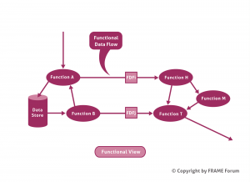](https://webcf.waybackmachine.org/web/20190124064754/http:/frame-online.eu/wp-content/uploads/2018/06/FRAME-Functional-View.png)

*Example Functional View*

## What is a Physical View?

[Home](https://webcf.waybackmachine.org/web/20190124064649/http:/frame-online.eu/)  [FRAME ARCHITECTURE](https://webcf.waybackmachine.org/web/20190124064649/http:/frame-online.eu/frame-architecture)  [FAQs](https://webcf.waybackmachine.org/web/20190124064649/http:/frame-online.eu/frame-architecture/faqs)  What is a Physical View?

Once the Functional View is complete, the architecture team allocates each function and data store to be located, either within a sub-system (see figure below), or within a module that is part of a sub-system. Once this has been completed the component (sub-system or module) specifications can be created from the definitions of the functions and data stores within them.

[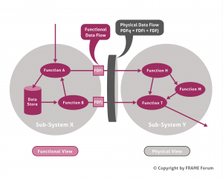](https://webcf.waybackmachine.org/web/20190124064649/http:/frame-online.eu/wp-content/uploads/2018/06/FRAME-Physical-View.png)

*Example Functional and Physical Views*

As can be seen from the figure above, a consequence of allocating functions and data stores to sub-systems (and modules), is that it is immediately clear which Functional Data Flows lie within a sub-system (or module), and which Functional Data Flows pass between one sub-system and another, or between one module and another. Those that pass between sub-systems or modules make up the Physical Data Flows, and represent a communication channel between sub-systems, and/or between modules.

Since sub-systems are, by definition, located in different places (e.g. in a traffic management centre, at the road side, in a vehicle) it is possible to produce communications specifications by analysing the contents of each Physical Data Flow. This analysis may elicit that an existing Standard may be used for the communications. Alternatively the analysis can be used as the basis for defining a new Standard if the need for it can be agreed.

Analysis of the Physical Data Flows that pass between the ITS and the Terminators can also lead to “standard” interfaces for end users, which can play an important part in making sure that the ITS implementation can be used in the same way, everywhere that it is deployed.

## What is a Stakeholder Aspiration?

[Home](https://webcf.waybackmachine.org/web/20190124064655/http:/frame-online.eu/)  [FRAME ARCHITECTURE](https://webcf.waybackmachine.org/web/20190124064655/http:/frame-online.eu/frame-architecture)  [FAQs](https://webcf.waybackmachine.org/web/20190124064655/http:/frame-online.eu/frame-architecture/faqs)  What is a Stakeholder Aspiration?

Stakeholder Aspirations are statements that express the expectations and desires of the various stakeholders for the services that the final ITS implementation will provide. Although they should be written by the stakeholders, experience has shown that they often need help from the architecture team. There are four classes of stakeholder, as follows:

• Want ITS – this class comprises (local) authorities and road operators who need ITS services to enable their roads to be used safely and efficiently. It also includes public transport operators and freight operators where ITS can enable them to improve the efficiency with which they move people and goods.

• Use ITS – this class comprises the end users who make use of the ITS services and/or operate the equipment. It includes travellers on a multi-modal journey as well as all classes of vehicle driver; freight shippers; pubic transport mangers and specialist system operators.

• Rule ITS – this class represents those who provide regulations and standards. It includes national governments and the various Standards making bodies.

• Make ITS – the class comprises the equipment and system manufacturers, communications providers and the system integrators.

Service providers, e.g. travel information and trip planning, may be in one or more of the Want, Use and Make ITS classes.

## What is a Terminator?

[Home](https://webcf.waybackmachine.org/web/20190124033429/http:/frame-online.eu/)  [FRAME ARCHITECTURE](https://webcf.waybackmachine.org/web/20190124033429/http:/frame-online.eu/frame-architecture)  [FAQs](https://webcf.waybackmachine.org/web/20190124033429/http:/frame-online.eu/frame-architecture/faqs)  What is a Terminator?

A Terminator is an entity that represents a part of the outside world with which the Framework Architecture interacts through an interface. It may be a person, or a system with which data can be exchanged, or a physical entity from which data can be obtained, such as the atmosphere, or road surface. Terminators provide the definitions of what the Architecture expects the outside world to do so that data can be exchanged. Persons can be End Users such as Travellers, or they may be part of organisations or public authorities that contribute in some way to the provision of ITS services. Systems may also be part of these organisations, or can be another instance of an ITS deployment.

Some Terminators are sub-divided into Actors when a particular sub-set of a Terminator needs to be identified within the Framework Architecture. e.g.

**Terminator:**  
Driver

**Actors**:  
Emergency Vehicle Driver  
Freight Vehicle Driver  
Hazardous Goods Vehicle Driver  
On-Demand Service Driver  
Private Driver  
Public Transport Driver  
Public Transport Touring Vehicle Driver  
Trip Planning Driver

## What is a User Need?

[Home](https://webcf.waybackmachine.org/web/20190124064659/http:/frame-online.eu/)  [FRAME ARCHITECTURE](https://webcf.waybackmachine.org/web/20190124064659/http:/frame-online.eu/frame-architecture)  [FAQs](https://webcf.waybackmachine.org/web/20190124064659/http:/frame-online.eu/frame-architecture/faqs)  What is a User Need?

User Needs provide a formalised description of the Services that will be provided through the deployment of the results from the creation of an ITS Architecture. What the Stakeholders themselves want should be expressed in their own words in their Stakeholders’ Aspirations. These Aspirations are then “mapped” to the User Needs so that a particular ITS Architecture can be created from the Framework Architecture. The resulting ITS Architecture is then used to plan the deployment of what is needed to deliver the Services (or aspirations) identified by the Stakeholders.

The User Needs are divided up according to the principal area in which the Services operate. Hence there are User Needs for: traffic management, freight movement, fleet operation, and public transport, plus facilities for electronic payment, law enforcement, security and incident response, links between vehicle and roadside, and traveller assistance.

Most User Needs are served by one or more Functions, and they are used to identify those parts of the FRAME Architecture that will be needed to satisfy the Stakeholders’ Aspirations. However, this matching cannot be exact and the architect must ensure final compleness and consistency (with the assistance of The Selection Tool).

User Needs that have no Functions listed in the Trace Tables relate to physical or communications requirements connected with the provision of the Services.

**An example User Need:**

6.1.2.13    The system shall be able to provide information to travellers so as to influence their choice of destination and/or mode of travel, e.g. to protect the environment of a “Point of Interest”, or geographic area.